LAB Logbook

Lab 1

Lab 2

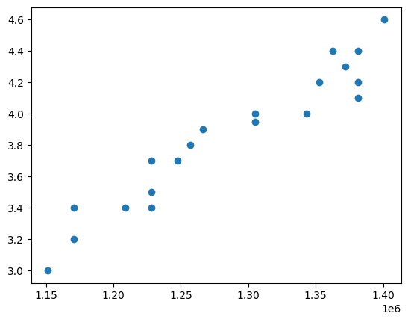

SID=1919019*0.75 =1439264.25

cost_guess = 4.3

Lab 3

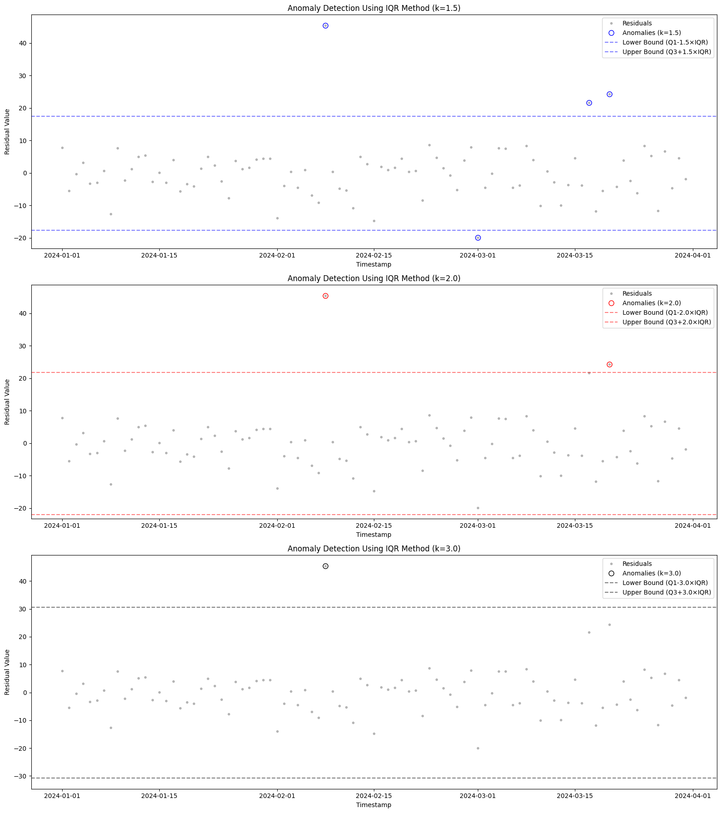

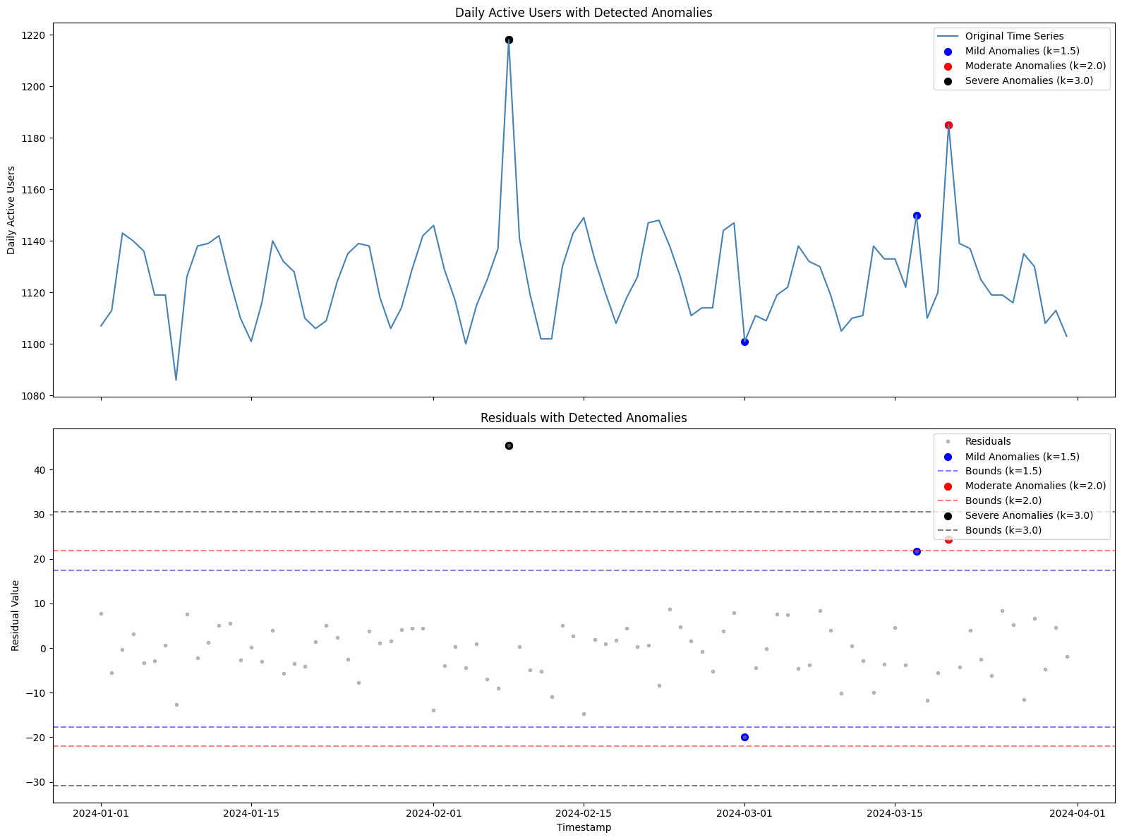

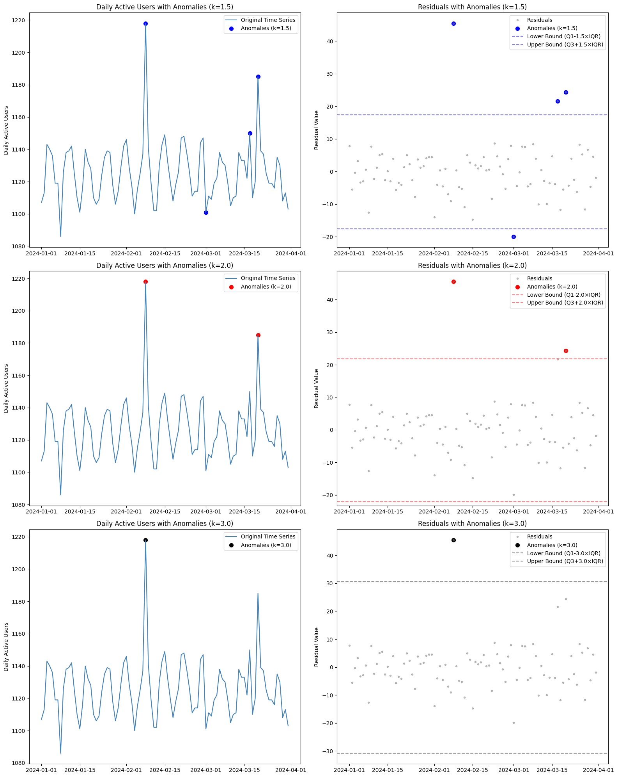

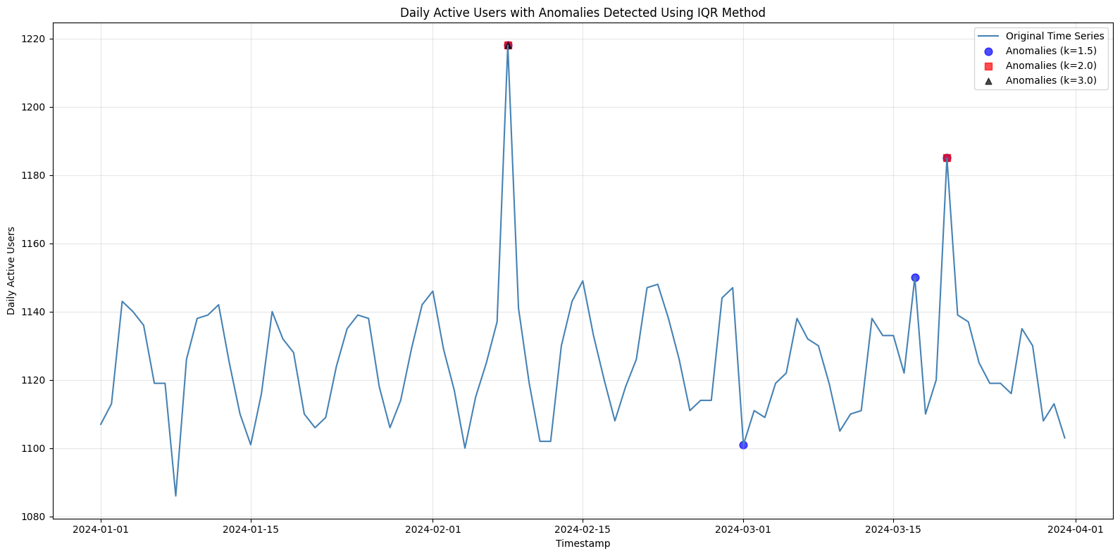

Lab 4

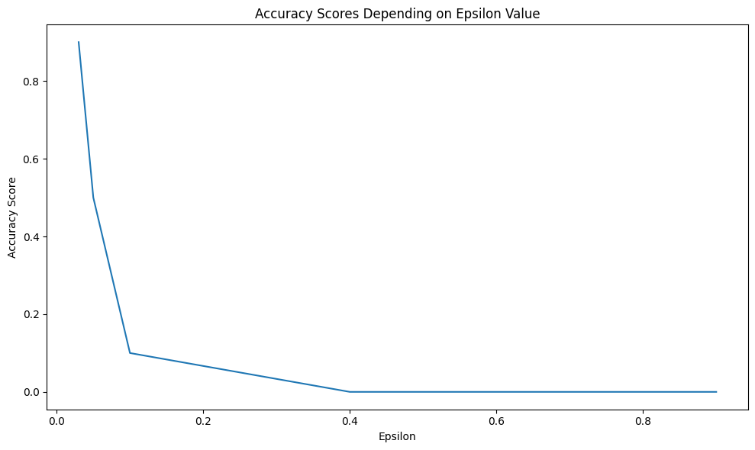

Accuracy before poisoning: 0.9772

Accuracy after poisoning: 0.0974

Lab 5

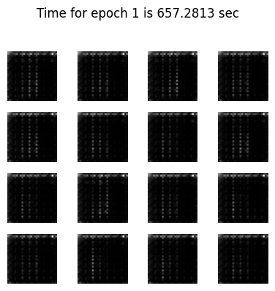

Time for epoch 1 is 657.2813 sec

Lab 6

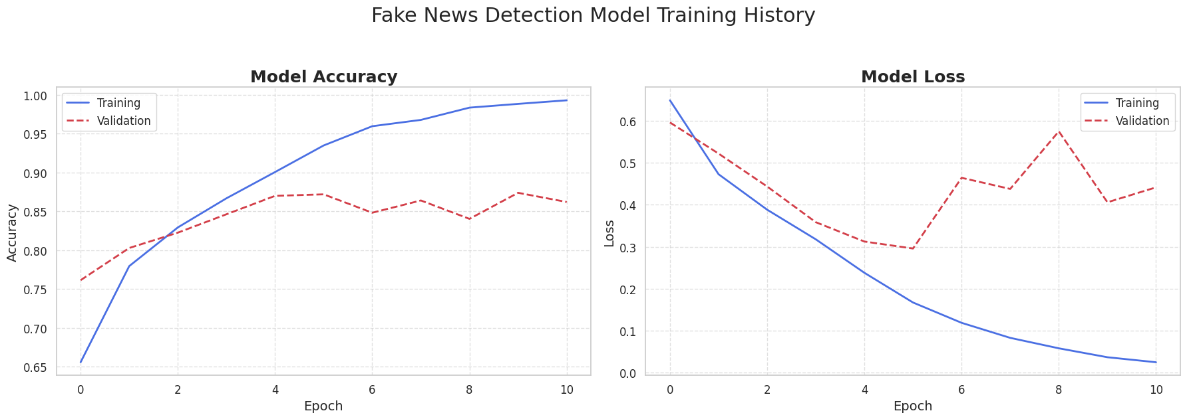

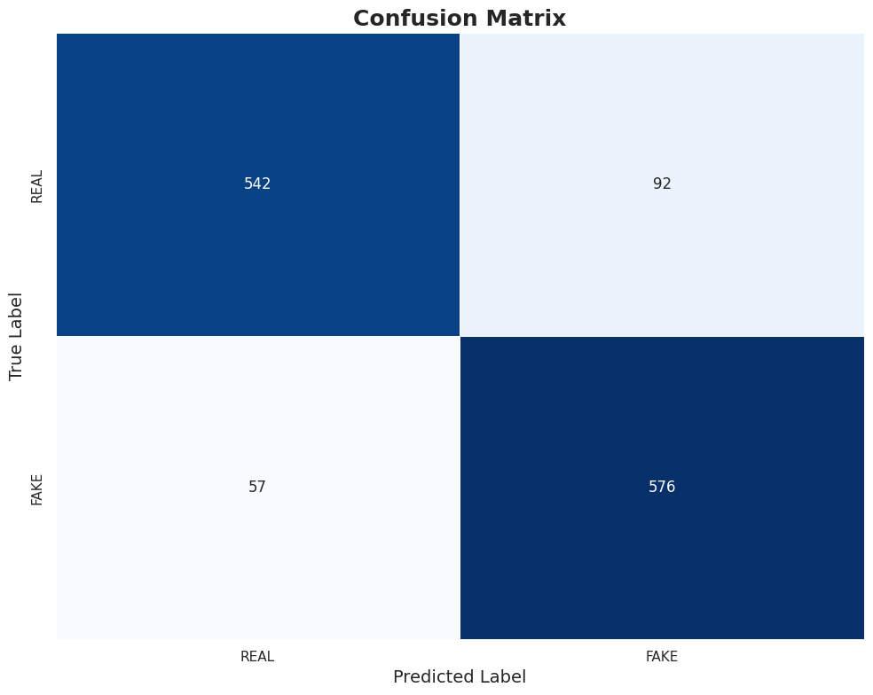

Lab 7

Modified input: hello

Encrypted text: WlRY7eYgnfQ=

Decrypted text: hello

user input cryptography

<class 'str'>

AES Encrypted: xd2DlKZ/1N0rOmHa6cijLA==

AES Decrypted: cryptography

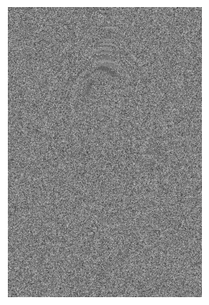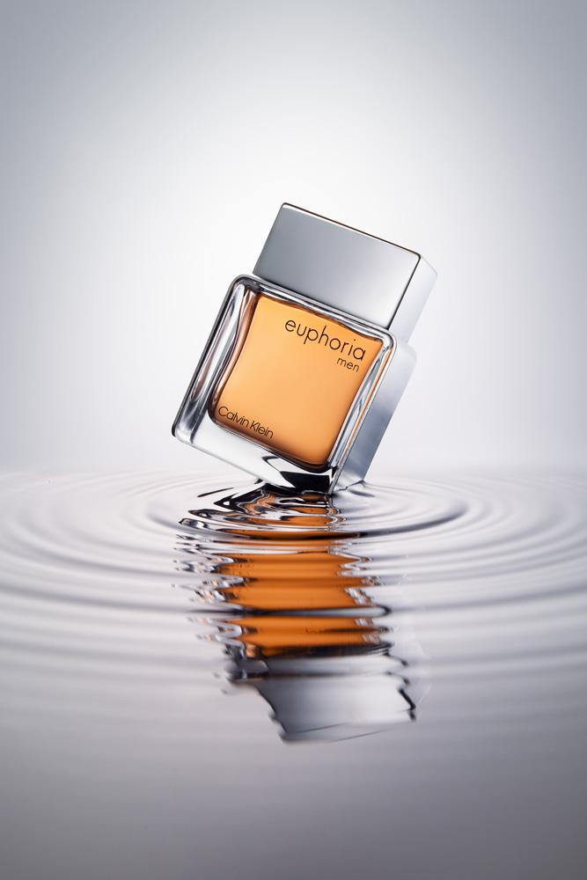

NO

Lab 8

Lab 9

1- 23andMe data breach (2022)

2-https://www.risk-strategies.com/blog/understanding-the-23andme-data-breach-and-ensuring-cybersecurity

Lab 10

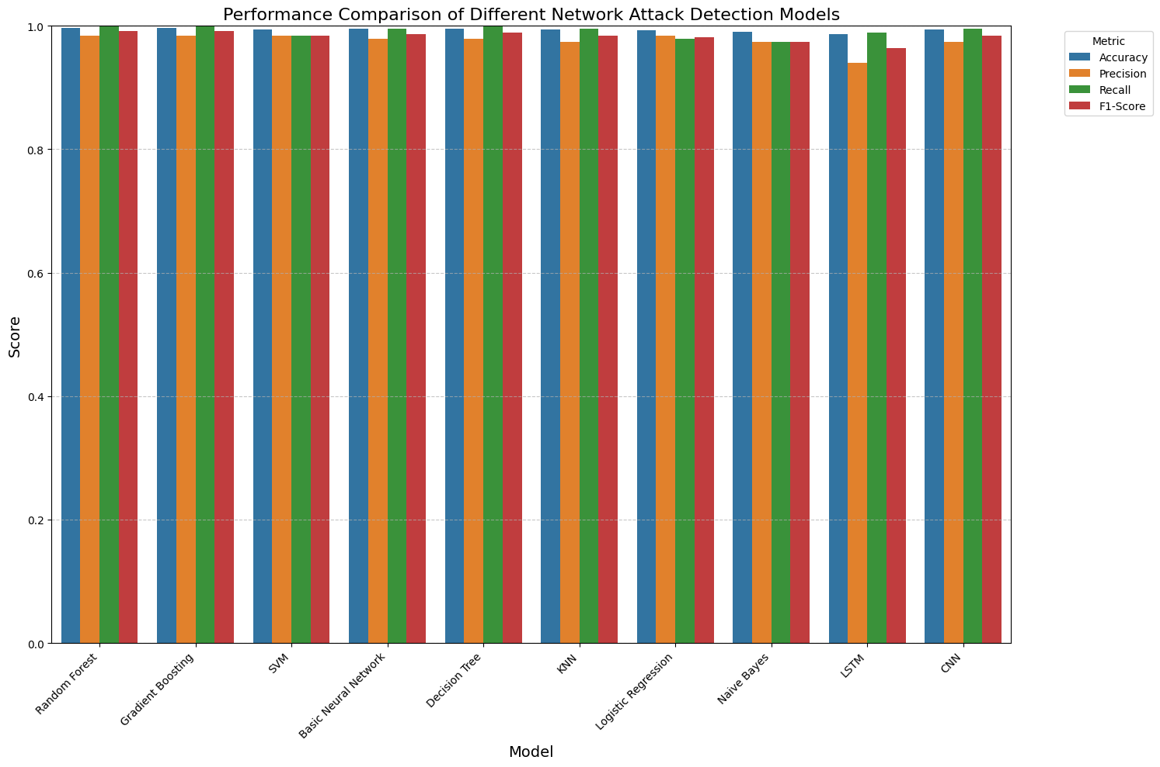

Lab 11

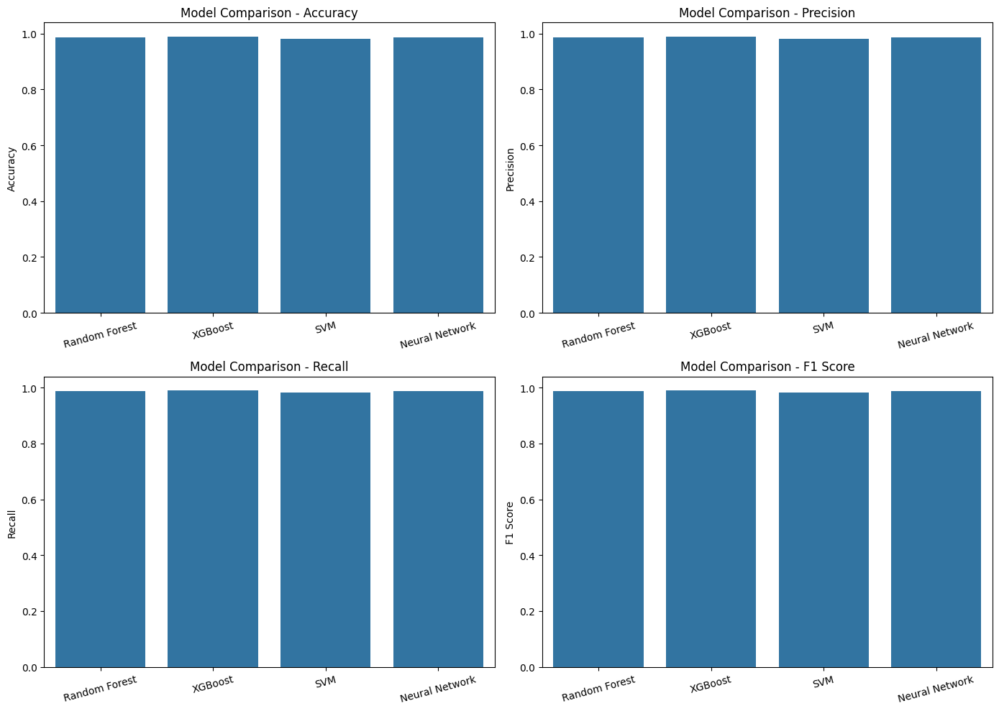

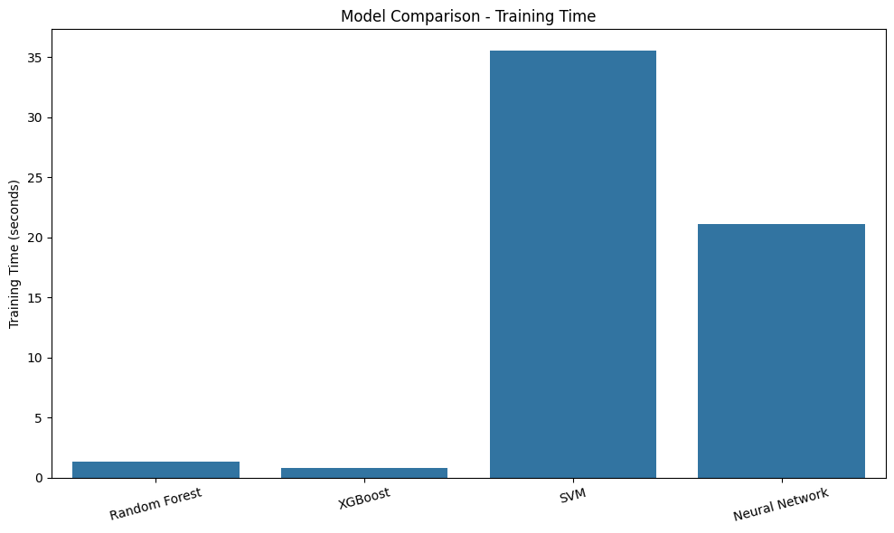

Lab 12

GitHub link - https://github.com/Salimboevm/Cyber-Security.git